**Assignments 2 ADTA 5750_NLP_Yog Chaudhary**

**Yog Chaudhary**

11727095

ADTA 5750 Applied Natural Language Processing

Professor: Dr. Thuan L Nguyen

University of North Texas **Sep 24, 2024**

**3. PART I: Request GCP Free Credit Coupon and Redeem It (10 Points)**

**We have created a services account for the GCP project.**

* Click on Access Google Chrome browser and open the IAM & Admin Services accounts page.
* Click IAM & Admin to open a drop-down menu.
* Click on Select Services accounts.
* Click to select a project name **yogchaudharyadta5750**
* Hare Screenshot.

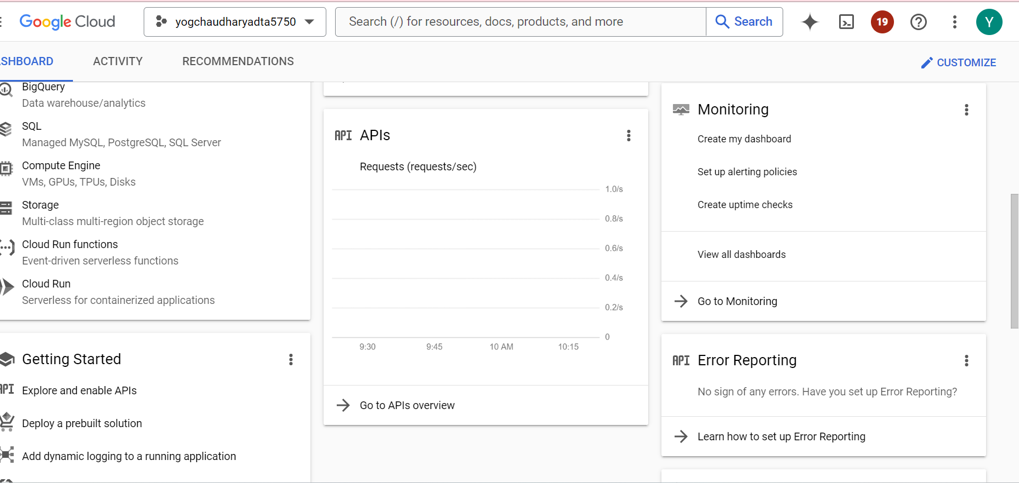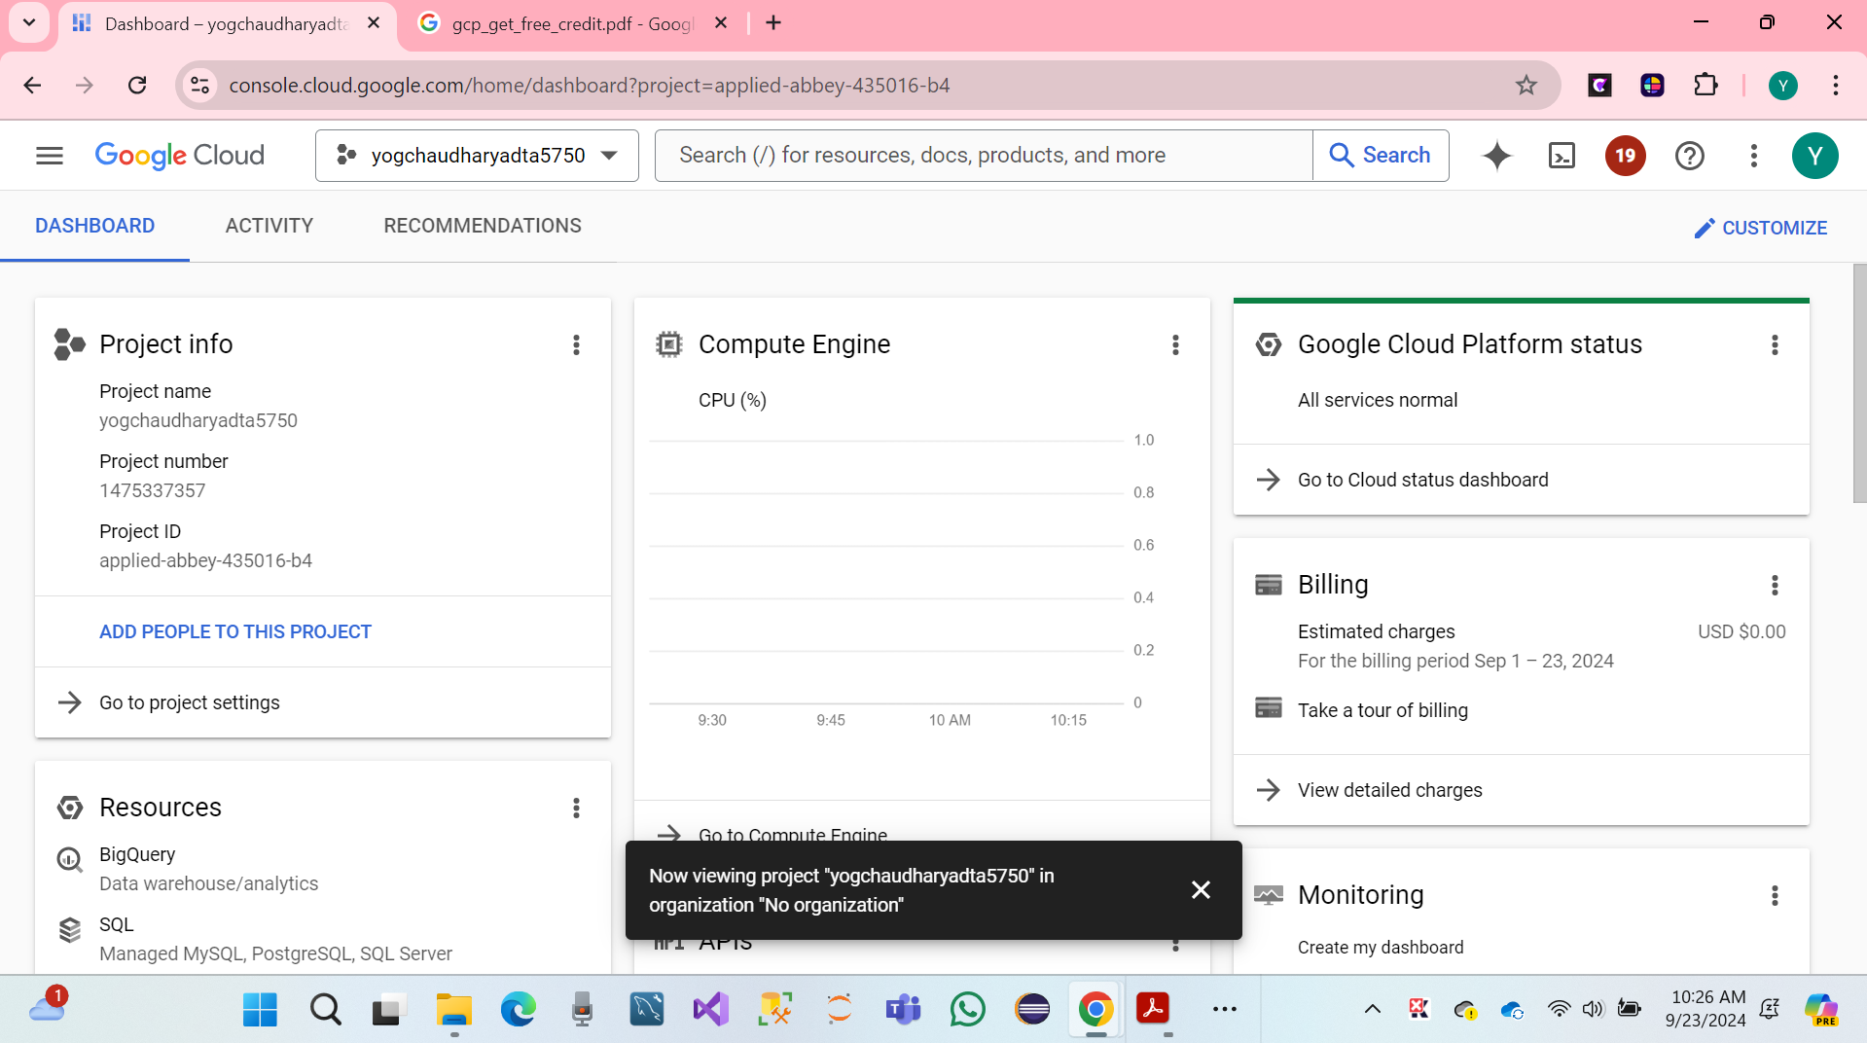

**4. PART II: GCP: Dialogflow CX: Fundamental Concepts (20 Points)**

We have a Discussion between in the GCP: Dialogflow CX the following concepts and used to design and managing conversion flows below listed on the submission requirement part ii:

**1 Conversation Session, a.k.a. Conversation or Session.**

**What is the concept:** A conversation session is also known as a session, which is an instance of a conversation between a user and a Dialogflow CX agent. Maintaining the context and, any state of the conversion.

**Role in AI Dialogue System:** The role in Ai Dialogue system, it manages or tracking the process of conversation and context management through the interaction.

**2. Agent**

**What is the concept:** Agent is a conceptual virtual entity that process user inputs and generators responses, which can be acting the core components of the dialogue system

**Role in AI Dialogue System:** The agent such as the interface between the user and the system, interpreting user intents and managing providing the conversion flow responses.

**3. Flow**

**What is the concept:** Flow is a collection of pages and transitions that define an important part of the conversation.

**Role in AI Dialogue System:** Flows helps organizations the conversation, int managerial and logical selection, which allows for complex dialogue modular design.

**4. Page**

**What is the concept**: A page representants a state in conversations, where the agent waiting for user inputs or performs.

**Role in AI Dialogue System:** A page helps guide the conversion, which defines actions and response at points in the interaction.

**5. State**

**What is the concept:** A state is the important condition or points in the conversion of which certain criteria are met, and actions, which can be executed.

**Role in AI Dialogue System:** States determine the flow of the conversation, which dictates transitions based on user inputs or other conditions.

**6. State Handler, a.k.a. Handler**

**What is the concept:** A state handler process user inputs and determines the next state or actions in the conversion.

**Role in AI Dialogue System:** A state handler ensures that the conversions logical progress, which managing transitions between states, and hander inputs.

**7**. **Intent**

**What is the concept**: The Internet represents a specific action or response that the user wants to achieve through conversation.

**Role in AI Dialogue System:** Internets helps the agents understand user goals and provided relevant responses to actions.

**8. Entity**

**What is the concept:** An entity is a data type that represents specific information extracted from user inputs, such as dates or names.

**Role in AI Dialogue System:** Entities allow the agent to capture and manage specific information with details from the conversions, enhancing the system ability to responses accuracy.

**Explanation:** All of these concepts are integral to designing and managing conversations in Dialogflow CX. They work together to create a structured dialogue system, enabling the AI to understand user intents, manage conversation states, and respond appropriately which, based on context extracted information, and understanding these components is essential for building effective AI dialogue systems.

**5. PART III: GCP: Dialogflow CX: Create a Virtual Agent (30 Points)**

**We have open chrome browser, and click on link** [**https://cloud.google.com/dialogflow/cx/docs**](https://cloud.google.com/dialogflow/cx/docs)

* **Click on go to the Dialogflow CX Console.**
* **Continues on select project name yogchaudharyadata5750**

* **Click om Enable API.**

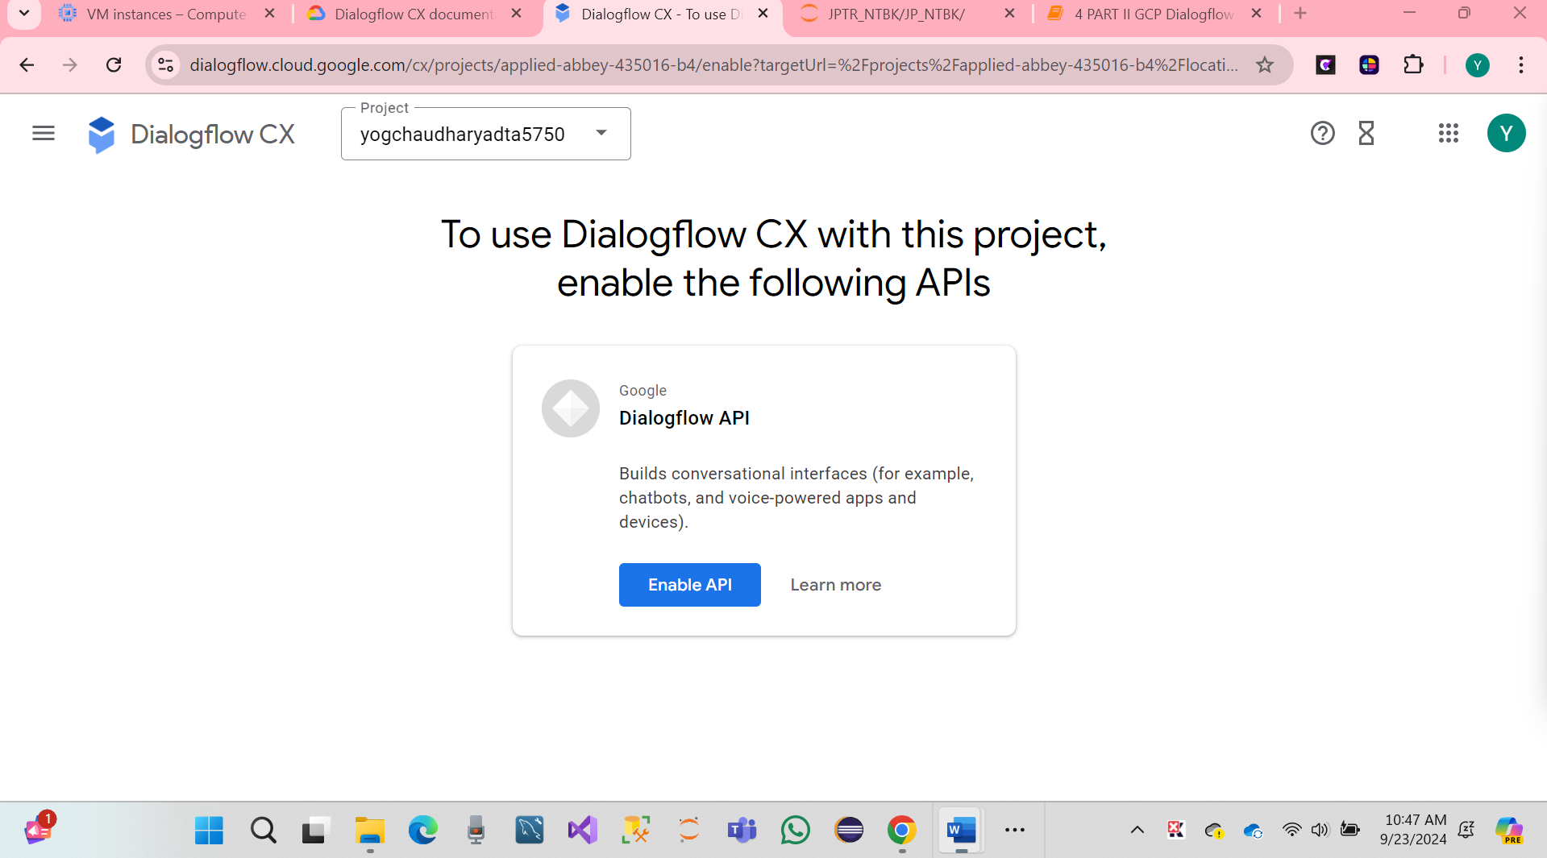

* **Click on continues Create agent.**

* **Hare Screenshot.**
* **Click on build your own.**

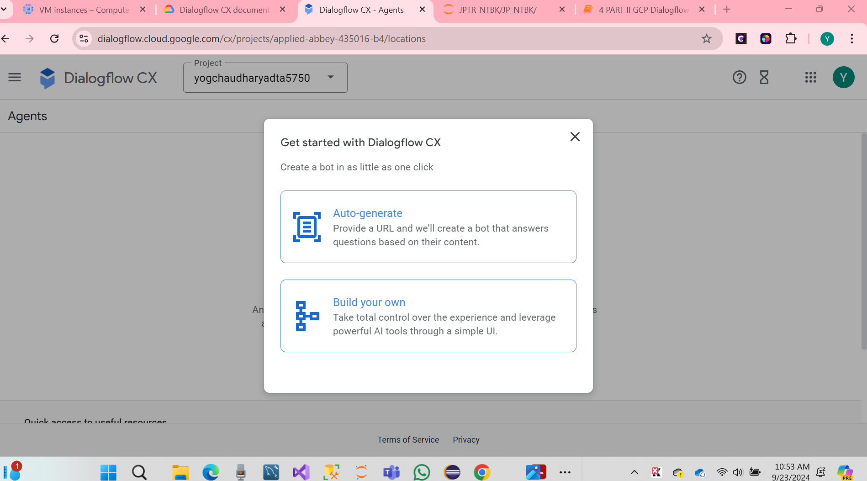

**Click on Build your own.**

**We have created agent has been successfully.**

**6. PART IV: GCP: Dialogflow CX: A Simple Conversation (40 Points)**

**We have click on the link** <https://dialogflow.cloud.google.com/cx/projects/applied-abbey-435016-b4/locations>,

This project was to design a customer-agent conversation flow for a retail store, **Retail Store_YOG**, using Google Dialogflow CX. The store sells medium-sized green shirts, and the conversation includes information about color, price, and size. This report outlines the steps taken to create and test conversation flow.

* Click on Create agent page name on the chose location.

We have created an agent, and assumed that a Retail Store Name**: Retail Store_YOG**

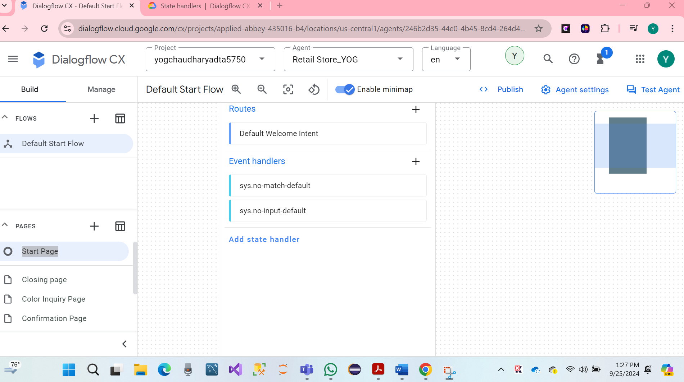Hare Screenshot

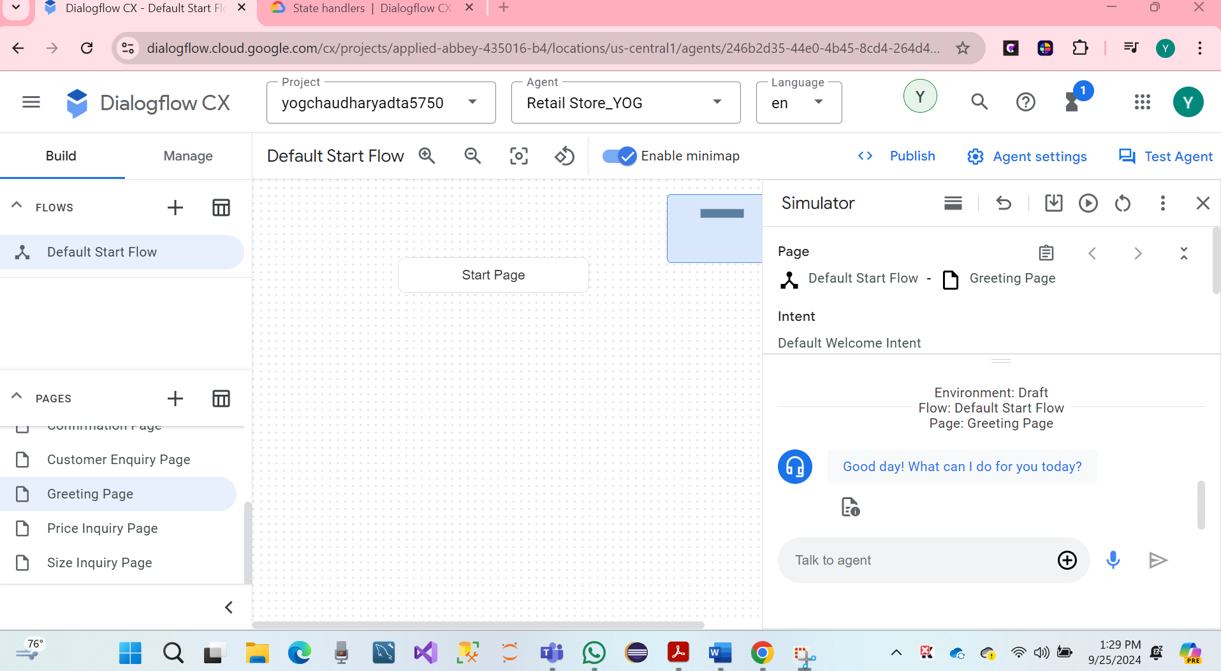

**Question 3.1:**

**(a) How many turns are there in the above conversation?**

We have given 11 turns conversation between **Customer C and Staff A**. So, Following there:

A: Good morning. How can I help you?

C: Good morning. I want to buy a shirt. What color do you have?

A: It’s green.

C: Great! How much is it?

A: $30.00

C: What size?

A: Medium. Is it OK for you?

C: Yes. I like it. I’ll get to the store and buy one.

A: We’re open until 7:00 PM tonight.

C: Thanks. Bye.

A: Thank you very much. Bye

**(b) Which turns should be included in “Default Start Flow” (See GCP: Dialogflow CX documentation)?**

In Dialogflow CX, including information to initiate the conversions, the following turns dialogue should be parts of the Default Start Flow:

Turn 1: A: "Good morning. How can I help you?"

Turn 2: C: "Good morning. I want to buy a shirt. What color do you have?"

Turn 3: A: "It’s green."

Turn 4: C: "Great! How much is it?"

Turn 5: A: "$30.00"

Customer Enquiry Page

**Question 3.2**

1. Following the information provided in the documentation of GCP: Dialogflow CX, design the conversation flow for the above dialogue.
2. Capture a screenshot(s) for each step of the designing process to show what has been done.
3. Write a report to discuss each step of designing the conversation flow in detail.

We have created **Dialogflow CX** design the conversation flow page. Each Process conversation between **Customer C and Staff A.**

* We have crated hare Screenshot on the Default Start Flow

* We have created a page named intent Greetings, and Agents say good morning. How can I help you?

* Each page same process with design Test Agents

* We have click on Gretting page, and Test Aget for chose page type hi

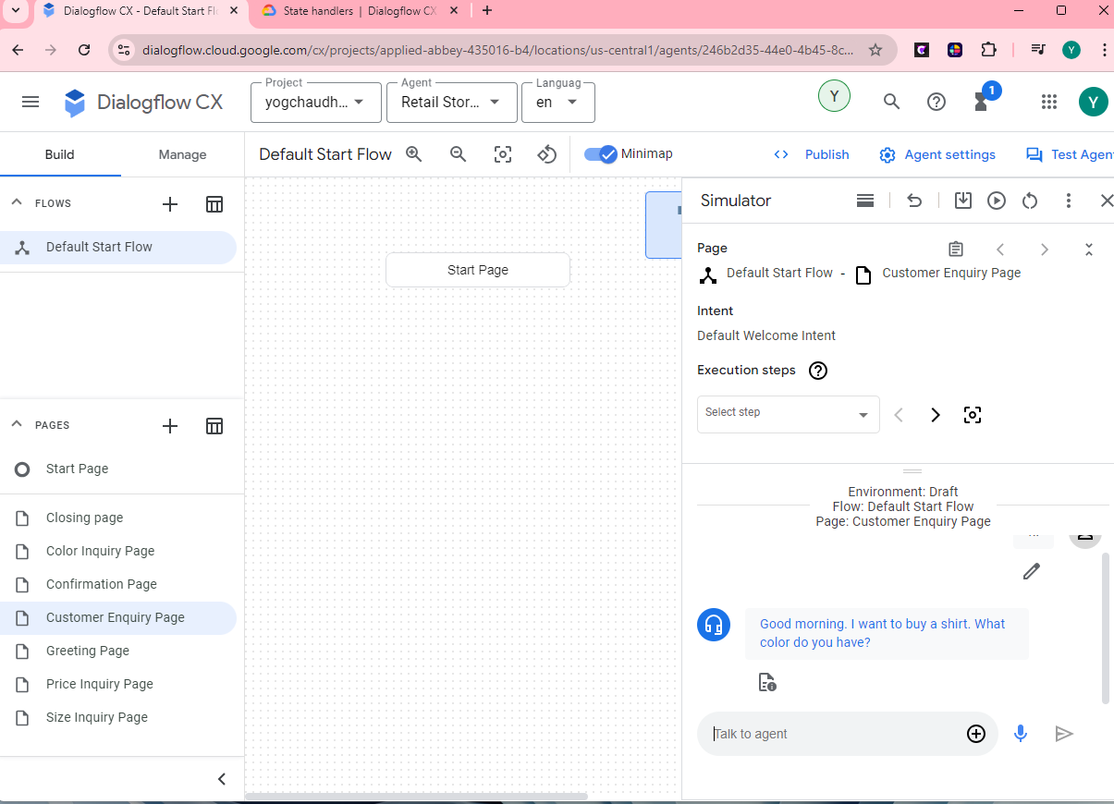

The covesristion flow for **Retai Store_YOG** was succefully designed, and all parts of the dialogue were propery adreesing using Dailogflow CX. The flow was test and vailidate, showing that can be handle cutomer queries about t-shirt color, price, size and store hourly.

**Question 3.3**

Based on the conversation design, provide the following pieces of information:

**(a): What conversation session does the design visualize?**

The conversion session visualizes an interaction between a customer and store assistance at **Retai Store_YOG.** The customer is inquiring about a medium-sized green shirt, its color, price, size, and store hours. The coversion follows a struacted all interction, and provided details, lending the cutomers to confirm their interest in purchases the shirt.

**(b): How many pages? What does each page refer to?**

We have 6 pages in the conversation flow, and each page of the conversion following.

* Greeting Page: The agent welcomes the customer and asks how they can assist.
* Color Inquiry Page: The agent informs the customer that the available shirt, and Discussion about the shirt's color.
* Price Inquiry Page: The agent provides the price ($30.00) when the customer asks for it.
* Size Inquiry Page: The agent informs the customer that the shirt is medium-sized.
* Confirmation Page: Confirmation of the purchase, when the customer expresses interest in buying the shirt.
* Closing Page: Ending the conversation with both parties saying goodbye.

**(c): How many states? What does each state refer to?**

There are six states, each state of the conversion following.

* Greeting State: Handles the initial greeting.
* Color Inquiry State: Manages the color-related inquiry.
* Price Inquiry State: Manages the price-related inquiry.
* Size Inquiry State: Manages the size-related inquiry.
* Confirmation State: Manages the purchase confirmation.
* Closing State: Manages the conversation closure.

**(d): Are there any state handlers? If YES, what are they?**

Yes, there are state handlers. They manage transitions between states based on user inputs, such as moving from the Greeting State to the Color Inquiry State when the user asks about the color.

**(e): Are there intents? What are they?**

Yes, there are intents are following.

* Color Inquiry Intent: For asking about the shirt's color.
* Price Inquiry Intent: For asking about the shirt's price.
* Size Inquiry Intent: For asking about the shirt's size.
* Purchase Confirmation Intent: For confirming the purchase.

**(f): Are there entities? What are they?**

Yes, there are entities that are following.

* Color Entity: Represents the color green.
* Price Entity: Represents the price $30.00.
* Size Entity: Represents the size medium.

Explanation: The conversation design in Dialogflow CX is structured around pages and states that correspond to different parts of the interaction. Each page and state handle specific inquiries or actions, with state handlers facilitating transitions based on user inputs. Intents capture the user's goals, while entities extract specific information from the conversation, allowing the system to respond accurately, maintain context and efficient dialogue flow.

**References**

[**https://www.youtube.com/watch?v=Xfgn9iA1KMk&list=PLJLSPq0cTRmat9ec-c0hOJJhhNfObZXy**](https://www.youtube.com/watch?v=Xfgn9iA1KMk&list=PLJLSPq0cTRmat9ec-c0hOJJhhNfObZXy)

[**https://www.youtube.com/watch?v=bpzSQTZ9MzI**](https://www.youtube.com/watch?v=bpzSQTZ9MzI)